Sorting It All Out
Time Limit: 1000MS |  | Memory Limit: 10000K
Total Submissions: 27587 |  | Accepted: 9551
Description
An ascending sorted sequence of distinct values is one in which some form of a less-than operator is used to order the elements from smallest to largest. For example, the sorted sequence A, B, C, D implies that A < B, B < C and C < D. in this problem, we will give you a set of relations of the form A < B and ask you to determine whether a sorted order has been specified or not.
Input
Input consists of multiple problem instances. Each instance starts with a line containing two positive integers n and m. the first value indicated the number of objects to sort, where 2 <= n <= 26. The objects to be sorted will be the first n characters of the uppercase alphabet. The second value m indicates the number of relations of the form A < B which will be given in this problem instance. Next will be m lines, each containing one such relation consisting of three characters: an uppercase letter, the character "<" and a second uppercase letter. No letter will be outside the range of the first n letters of the alphabet. Values of n = m = 0 indicate end of input.
Output
For each problem instance, output consists of one line. This line should be one of the following three:
Sorted sequence determined after xxx relations: yyy...y.
Sorted sequence cannot be determined.
Inconsistency found after xxx relations.
where xxx is the number of relations processed at the time either a sorted sequence is determined or an inconsistency is found, whichever comes first, and yyy...y is the sorted, ascending sequence.
Sample Input
4 6
A<B
A<C
B<C
C<D
B<D
A<B
3 2
A<B
B<A
26 1
A<Z
0 0
Sample Output
Sorted sequence determined after 4 relations: ABCD.
Inconsistency found after 2 relations.
Sorted sequence cannot be determined.
Source

4 6
A<B
A<B
C<D
A<C
B<C
B<D
3 2
A<B
B<A
26 1
A<Z
0 0

6 6
A>B
B>F
B>C
F>D
C>D
D>E

不过最后为什么是else if？

#include <iostream>
#include <queue>
using namespace std;
struct node
{
int pos;
int next;
};
node info[1001];int indegree[1001],degree[1001],sets[1001];
int sequence[1001];int n,m;
int toposort()
{
queue<int>q;
int i,k=0,t;
for(i=0;i<n;i++)
{
degree[i]=indegree[i];
if(degree[i]==0) q.push(i);
}
bool judge=false;
while(!q.empty())
{
if(q.size()>1) judge=true;
int temp=q.front();
q.pop();
sequence[k++]=temp;
t=sets[temp];
while(t!=-1)
{
degree[info[t].pos]--;
if(degree[info[t].pos]==0) q.push(info[t].pos);
t=info[t].next;
}
}
if(k<n) return -1;
if(judge) return 0;
return 1;
}
int main()
{
while(cin>>n>>m&&(n||m))
{
int i;char str[4];int current=0;int ans=-1,error=-1;
for(i=0;i<n;i++)
{
indegree[i]=0;
sets[i]=-1;
}
for(i=0;i<m;i++)
{
cin>>str;
if(ans!=-1||error!=-1) continue;
int begin=str[0]-'A';
int end=str[2]-'A';
info[current].pos=end;
info[current].next=sets[begin];
sets[begin]=current;
current++;
indegree[end]++;
int judge=toposort();
if(judge==1) ans=i+1;
if(judge==-1) error=i+1;
}
if(ans!=-1)
{
cout<<"Sorted sequence determined after "<<ans<<" relations: ";
for(i=0;i<n;i++)
cout<<char(sequence[i]+'A');
cout<<"."<<endl;
}
else if(error!=-1)
{
cout<<"Inconsistency found after "<<error<<" relations."<<endl;
}
else
cout<<"Sorted sequence cannot be determined."<<endl;
}
return 0;
}

这是一道比较典型的拓扑排序
其成员函数 toposort 可用作模板

写一下结题报告
首先结构体里的 pos 指的是现在处于begin 位置的字母 next 指的是从当前状态 sets[i] （不等于-1时） 要返回的状态 因为如果不等于-1 说明该字母在begin 位置 出现了两次
而 sets 记录了他最后一次出现 是在第几组数据之中 找到这组数据后 再通过next 找到上一次 他在begin位置出现的数据
简而言之 sets[i]记录的是i最近一次他在begin位置 出现的数据的组数
而 info[i].next和他类似

以A<B A<C B<C为例
在进入t！=-1 这个循环后 先找的是C 然而C的degree 不为1 往下继续找 找到上一次他出现的那组数据 A<B degree[B]为一 所以把B 放入队中
值得注意的是
每一组正常的数据 如A<B B<C C<D D<E
在其中加入任何一组 多余的 如 B<E 都会导致 end处的字母的入度不唯一 所以在循环时 不会被输出

同时 队列中始终只能有一个数
除非出现了环 但是环是不符合情况的
如
F
A B D E
C
这时候局部成环 队列中会出现F C 两个数
而若是全部城环的话 队列中会一个数都没有 同样不对
在考虑一下 有两组矛盾的情况
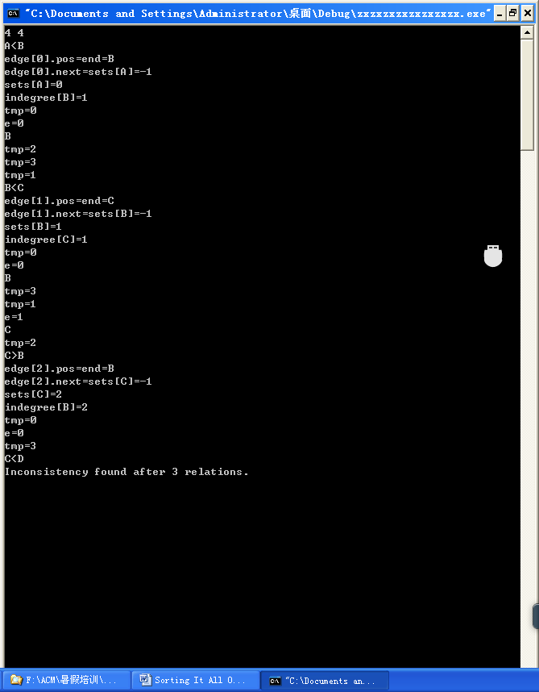

我感觉他在toposort时 并不是一组组的遍历 而是利用之前 存在数组中的数据 在各个组中跳转 进行判断

还有些情况
A<B
A<B
………
他一定会跳到第一个 A出现的地方

我觉得这道题最新 最没见过的地方 就是 sets 和 next

用sets 来记录 begin 出现的状态

观察一下不难发现规律 积累一下
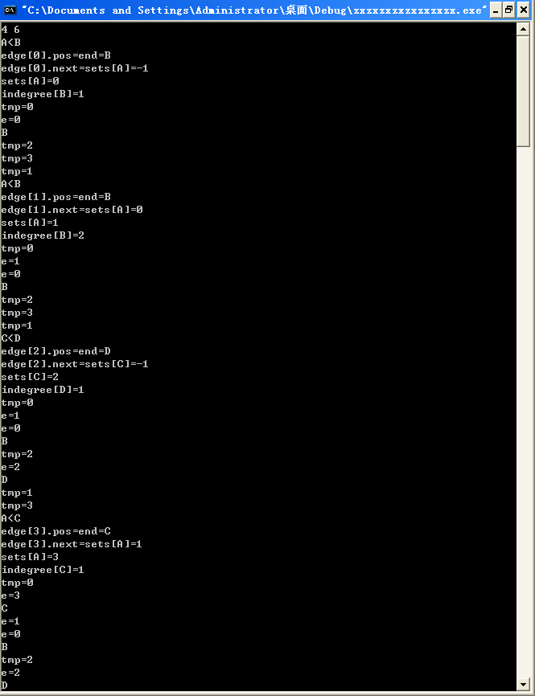

附上测试用 代码
#include <iostream>
#include <cstdio>
#include <algorithm>
using namespace std;
struct Edge
{
int pos;
int next;
}edge[405];
int cur;
int sets[26];
int n, m;
int indegree[26];
int queue[28], front, rear;
int seq[26];
int toposort()
{
int indeg[26];
bool judge = false;
front = rear = 0;
for (int i = 0; i < n; ++i)
{
indeg[i] = indegree[i];
if (indeg[i] == 0) queue[rear++] = i;//等于零的那一个没有入度 说明是队首 进队 所以如果成环了 队伍就为空
}
int k = 0;
while (front != rear)//队列不为空
{
if (front + 1 < rear) judge = true;//说明进来了超过两个数 有点未被纳入拓扑结构 确实不对
int tmp = queue[front++];//弹出队首元素
seq[k++] = tmp;//放入一个新队列中用于检测
cout<<"tmp="<<tmp<<endl;
int e = sets[tmp];//检查他下一个有没有

while (e != -1)//如果有
{
cout<<"e="<<e<<endl;
--indeg[edge[e].pos];
if (indeg[edge[e].pos] == 0) {queue[rear++] = edge[e].pos;cout<<char(edge[e].pos+'A')<<endl;}//如果那一点的入度为1 入队
e = edge[e].next;
}
}
if (k < n) return -1;//没进行完有矛盾
if (judge) return 0;
return 1;//对的
}
int main()
{
char str[5];
int beg, end;
int err, ans;
while (scanf("%d%d", &n, &m) != EOF)
{
if (!n && !m) break;
for (int i = 0; i < n; ++i)
{
indegree[i] = 0;//一开始入度都为零
sets[i] = -1;//一开始都没有后继者
}
cur = 0;
err = ans = -1;
for (i = 0; i < m; ++i)
{
scanf("%s", str);
if (err != -1 || ans != -1) continue;
beg = str[0] - 'A';
end = str[2] - 'A';
edge[cur].pos = end;//现在的结束位置是B
edge[cur].next = sets[beg];//B的下一个位置为-1
cout<<"edge["<<cur<<"].pos=end="<<char(edge[cur].pos+'A')<<endl;
cout<<"edge["<<cur<<"].next=sets["<<char(beg+'A')<<"]="<<edge[cur].next<<endl;
sets[beg] = cur;//此时队首元素A 设为有后继者0 下面再来A C队首元素依旧为A 后继者变为一了
cout<<"sets["<<char(beg+'A')<<"]="<<sets[beg]<<endl;
++cur;//cur变为一了 说明对中排好顺序的有两个元素了
++indegree[end];//以A B为例 B的入度加一
cout<<"indegree["<<char(end+'A')<<"]="<<indegree[end]<<endl;
int judge = toposort();
if (judge == 1) ans = i + 1;
else if (judge == -1) err = i + 1;
}
if (ans != -1)
{
printf("Sorted sequence determined after %d relations: ", ans);
for (int i = 0; i < n; ++i) putchar('A' + seq[i]);
printf(".\n");
}
else if (err != -1)
{
printf("Inconsistency found after %d relations.\n", err);
}
else
{
printf("Sorted sequence cannot be determined.\n");
}
}
return 0;
}

